Subscriber moves – Broadband and optional Voice service

Version Control:

Use Case Name: |  | Subscriber moves – Broadband and optional Voice service
Use Case Owner: |  | Sumit Borade
Current Version |  | 0.2
Use Case Version History
Modified Date | Version |  | Modified By | Change Description
July 8, 2009 | 0.1 |  | Tom Schnarr | Initial Version
Oct 28,2009 | 0.2 |  | Sumit Borade | Re provision Static IP Service

Brief Description:
This use case describes the process by which a YouSee subscriber moves from one residence to another.
The use case is written from the perspective of the SMP provisioning solution.

Related Documents
- YouSee SMP SOW2Architecture Requirements Document
- YouSee SMP SOW2 Business Requirements Document
- Voice over Cable Use Case Activation
- Cisco BACC TC Specification
- Cisco BTS TC Specification
- Static IP Notification Specification

Related Use Cases

Pre-Conditions
- Subscriber is an active broadband over cable subscriber.

Post-Conditions
- Subscriber is able to use the broadband service at the new service address.

Use Case

Primary Flow Diagram
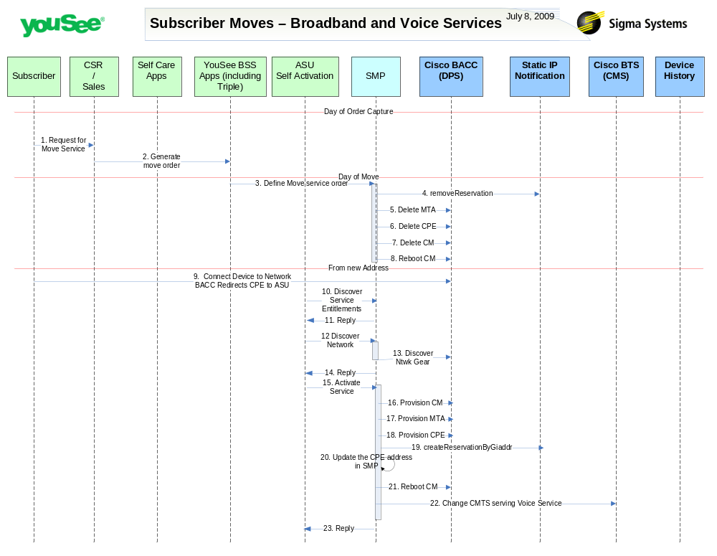

Primary Flow Detail
# | Actor: Key Action | Description | Alternate Flows/Details
Note: The first few steps in the use case occur when a move order is captured. This may be on the same day as the move or future dated for later activation
 | Subscriber: Contacts YouSee CSR and notifies of a move within YouSee Footprint | Current YouSee broadband subscriber contacts YouSee and makes a request to change their service address. The day of the order is included
 | CSR: Order is created in YouSee BSS applications | The Customer Service Representative defines the order in YouSee BSS Applications (Triple).  The BSS components perform a variety of qualification and product catalog decomposition.
Note: The following steps in the use case occur during the morning of the scheduled move.
 | YouSee BSS: Order is communicated to SMP | YouSee BSS (Triple) will communicate the order to SMP through SMP’s Order Management API. Triple will provide logical services and service attributes. SMP will be required to translate these service/service attributes to engineering level resources and resource attributes.
 | SMP: Removes the Static IP Reservation | SMP will remove the Static IP Reservation on YouSee static IP Notification System as the CMTS can change from New address.
 | SMP: deletes MTA from BACC | SMP will deprovision the MTA from BACC
 | SMP: deletes CPE from BACC | SMP will deprovision the CPE from BACC
 | SMP: deletes CM from BACC | SMP will deprovision the CM from BACC
 | SMP: requests BACC to reboot the CM Device | SMP will then request BACC to reboot the CM device resulting in the CM getting the new configuration, MTA to go offline and CPE to be assigned a new public IP Address.
Note: The following steps in the use case occur on the time of activation, that is when the subscriber is at the new premises and can connect the device.
 | Subscriber: Installs CM and PC and launches a browser. Network (BACC) redirects browser to ASU | <As in Activate Broadband Service Use Case>
 | ASU: request service entitlements from SMP | <As in Activate Broadband Service Use Case>
 | SMP: SMP sends reply to ASU for Service Entitlement Information | SMP will reply to ASU the Services present in SMP for that particular Subscriber account.
 | ASU: requests SMP to discover network gear | <As in Activate Broadband Service Use Case>
 | SMP: queries BACC and internal inventory to find network gear serving subscriber | <As in Activate Broadband Service Use Case>
 | SMP: Replies back to ASU the information received from CISCO BACC | SMP will reply back to ASU information retrieved from CISCO BACC for CPE IP address.
 | ASU: requests SMP to activate service | <As in Activate Broadband Service Use Case>
 | SMP: defines CM in BACC | <As in Activate Broadband Service Use Case>  Definition of CM attributes takes the voice service into account
 | SMP: defines MTA in BACC | The MTA is provisioned in BACC with the appropriate services
 | SMP: defines CPE in BACC | <As in Activate Broadband Service Use Case>
 | SMP: Provision static IP Service | <As in Activate Broadband Service Use Case>
 | SMP: Store the static IP address in SMP Data base | <As in Activate Broadband Service Use Case>
 | SMP: requests BACC to reboot the CM Device | <As in Activate Broadband Service Use Case>
 | SMP: defines new CMTS in BTS | Sigma will update the configuration of the Voice service in BTS, defining the new CMTS serving the subscriber
 | SMP: Reply back Status to ASU | SMP will reply back status to ASU

